Lab 03 – SQL – Single Table Queries

Objectives

The purpose of this lab is to start learning SQL by writing basic DML statements involving a single table.  You will learn to create basic CRUD statements (queries as well as insert, update and delete).

Submission:

***Your submission will be a single Word document with the question#, SQL query, solutions if it is a text or a screen shot provided. (with a .docx file extension)***. **Create a comment header that includes your name, student id, the date and the purpose of the file.**

**(i.e. Coursecode – Lab 03_firstname).**

Setup

Create a new worksheet in SQL developer and add an appropriate comment header that includes your name, student id, the date and the purpose of the file (i.e. **Coursecode – Lab 03_firstname**).   After every command and result in each question paste them in your Word file

Immediately under the comment header, enter the following line and then execute it:

SET AUTOCOMMIT ON;

Style Guide

Your SQL should be written using the standard coding style:

* all keywords are to be upper case,
* all user-defined names are to be lower case, (example: table and field names)
* there should be a carriage return before each major part of the SQL statements (i.e. before SELECT, FROM, WHERE and ORDER BY)

Using comments to number the question answers, write the SQL code to complete the following tasks.

**Tasks:**

1. Display the first 15 rows of data for the RETAILPAYMENTS table. (query and results in Word file).

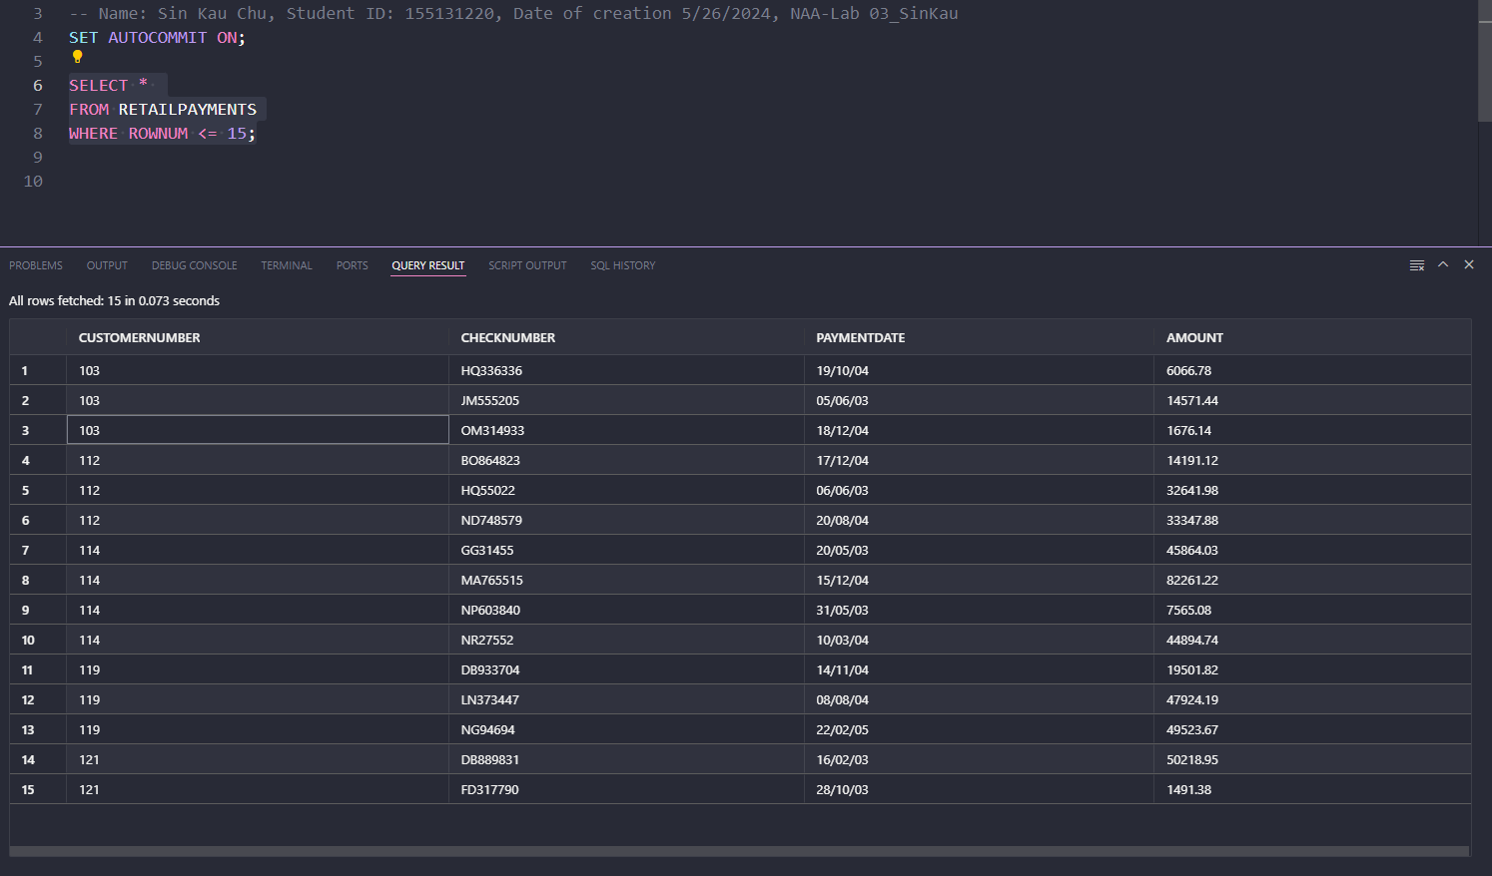

1. Display the full name of RETAILEMPLOYEE (in 2 ways) along with their email using the RETAILEMPLOYEEs table whose office code is 6. Example “John Smith [john@example.com](mailto:john@example.com)”

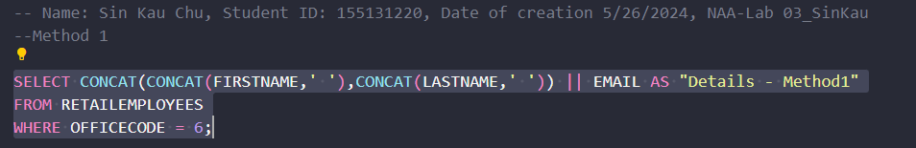

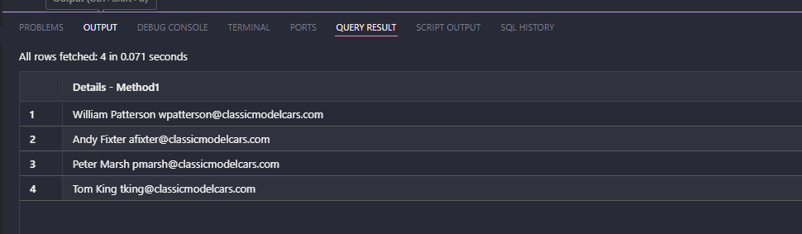

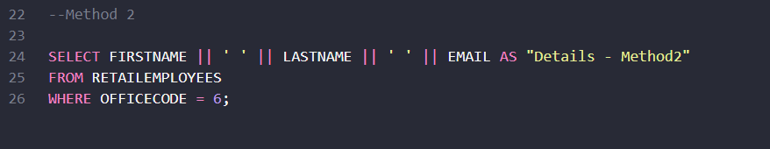

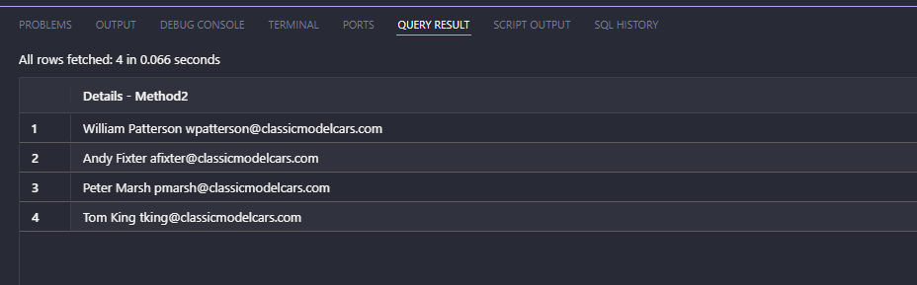

1. Display RETAILCUSTOMER number, RETAILCUSTOMER name, contact first name and contact last name, and phone for all RETAILCUSTOMERs in Singapore. (**hint**: be wary of case sensitivity)

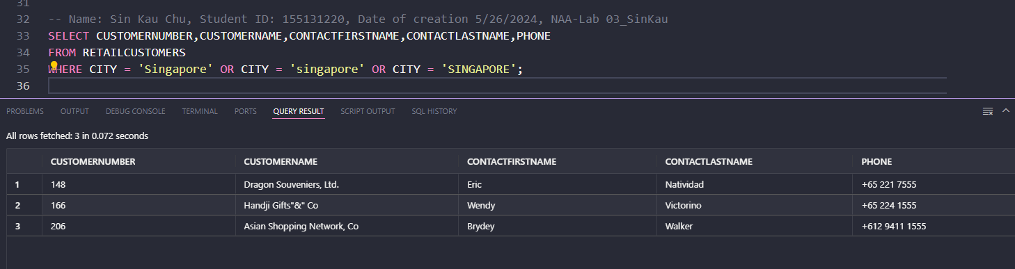

1. Repeat the previous Query with a couple of small changes:
2. The contact’s first and last name should be in a single column in the format “lastname, firstname”.
3. Show RETAILCUSTOMERs who have creditlimit in the range 60,000 to 90,000

The database having no record for above condition with city is Singapore

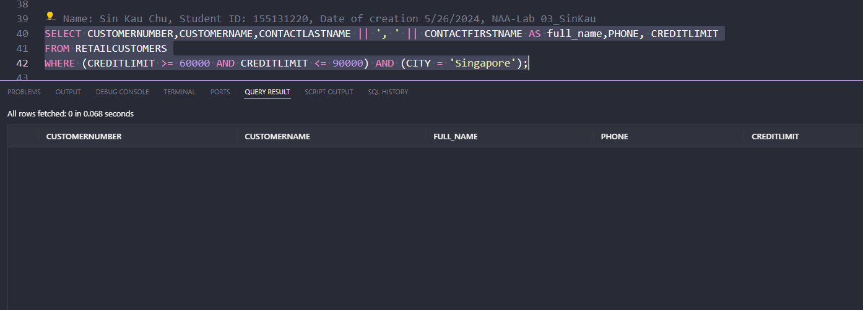

The following is the result for all cities

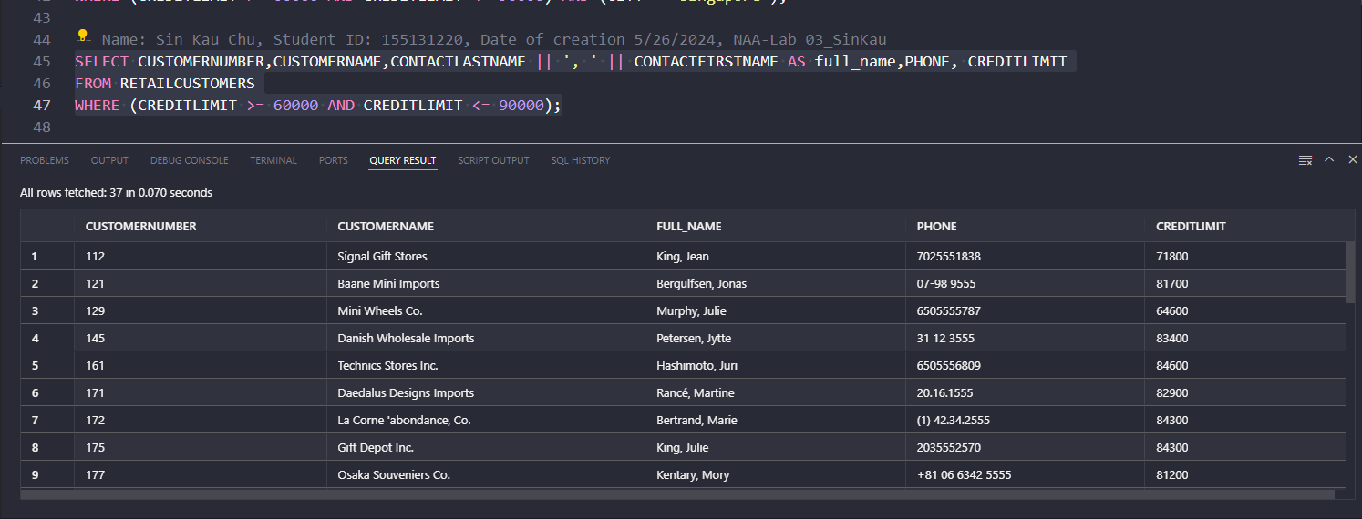

1. Display RETAILCUSTOMER number for RETAILCUSTOMERs who do not have addressline2.

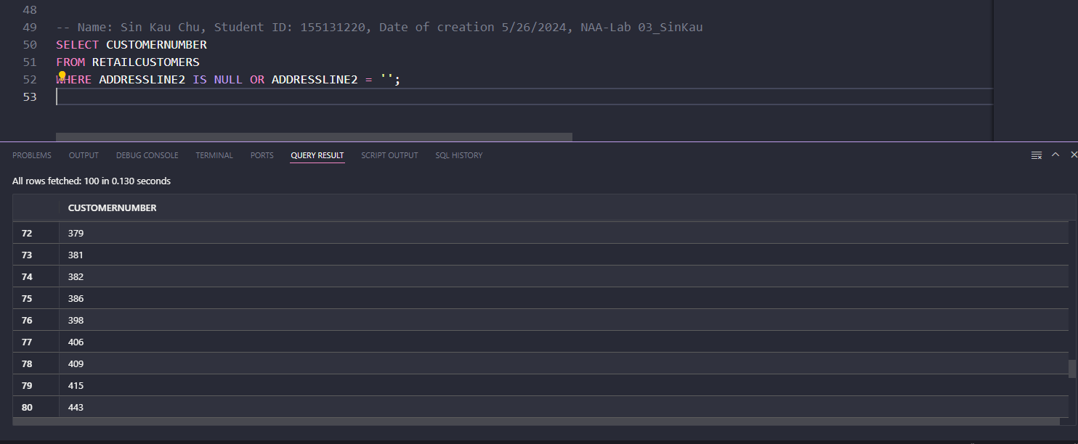

1. List CUSTOMER numbers, check number, and amount for RETAILCUSTOMERs whose payment amount is not in the range of $30,000 to $65,000 and who have payed in the year 2004.  Sort the output by top payments amount first.

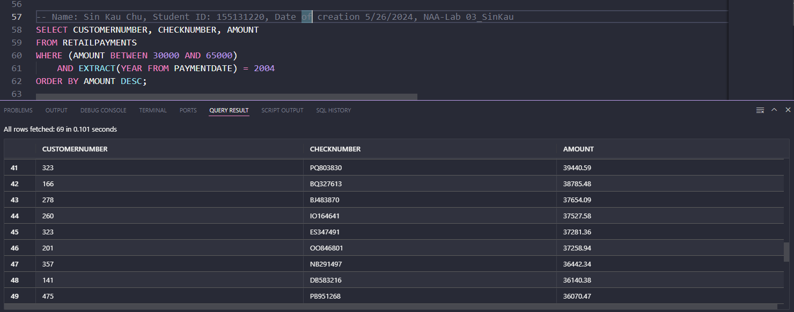

1. Display the order information for all RETAILORDERS that are cancelled in the year 2003

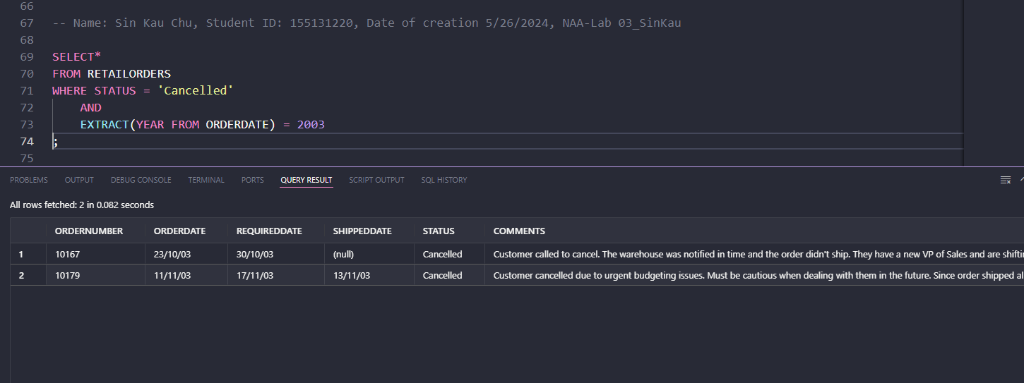

1. The company needs to know the percentage markup for each RETAILPRODUCT sold.  Produce a query that outputs the ProductCode, ProductName, BuyPrice, MSRP in addition to
2. The difference between MSRP and BuyPrice (i.e. MSRP-BuyPrice) called *markup*
3. The percentage markup (100 * calculated by difference / BuyPrice) called *percmarkup*   
   rounded to 1 decimal place.

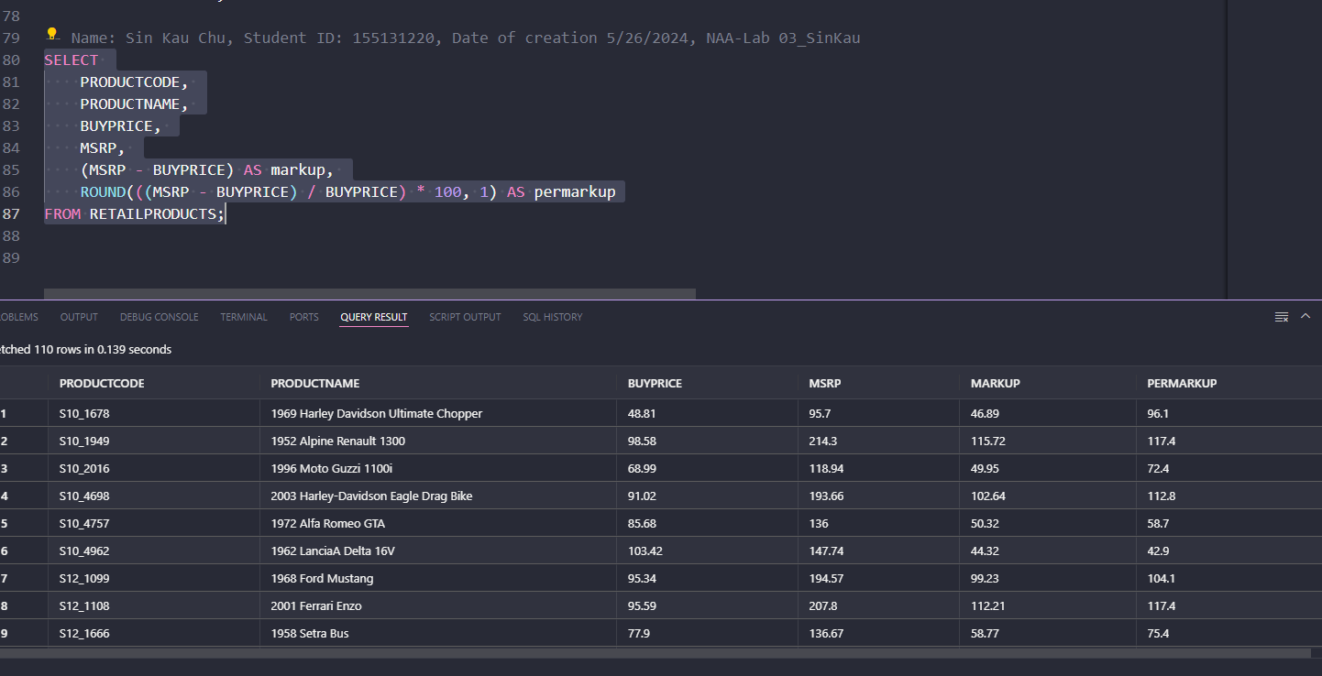

1. Display the information of all RETAILPRODUCTs with string ‘Ford***’*** in their product name. (c and o can be lower or upper case).

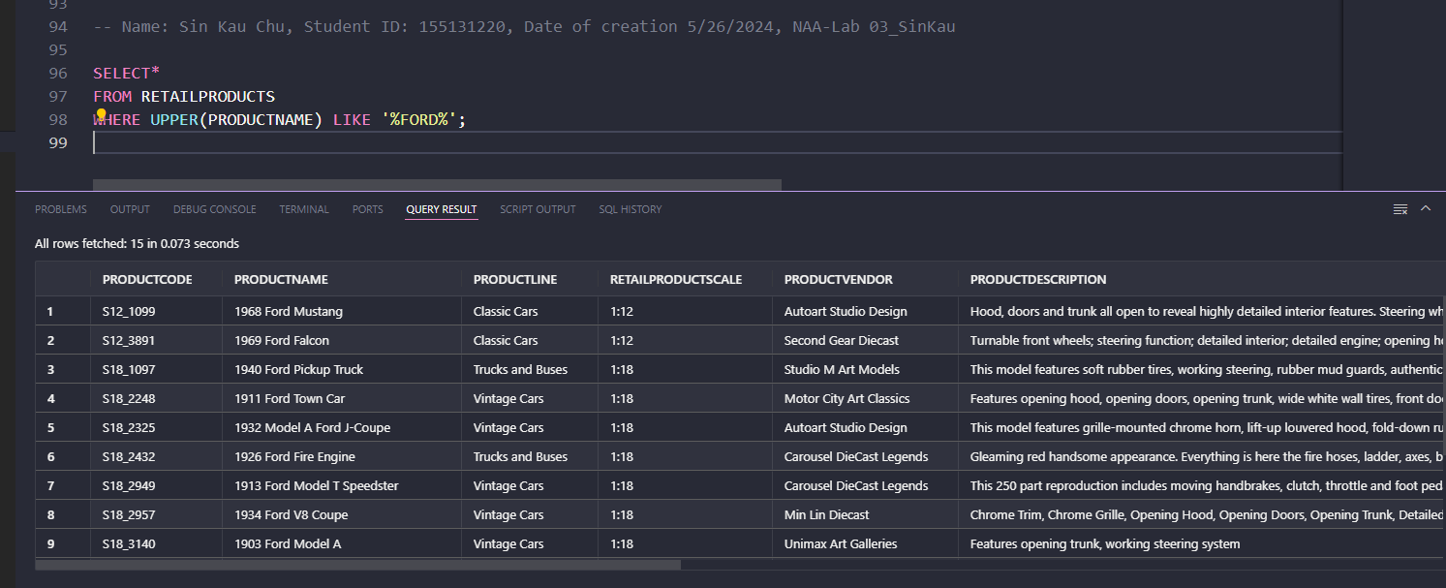

1. Display all RETAILCUSTOMERs whose contact first name ends with letter y (both lowercase and uppercase) and includes letter a (both lowercase and uppercase).

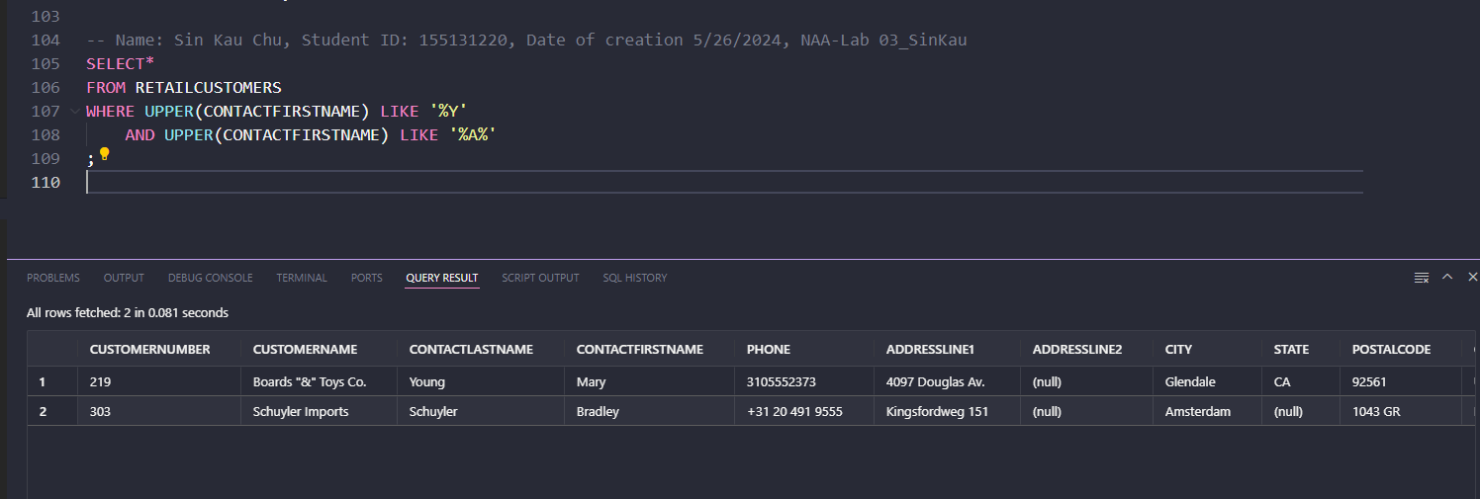

1. Create a statement that will insert yourself as an RETAILEMPLOYEE of the company.
2. Use a unique RETAILEMPLOYEE number of your choice
3. Use your school email address
4. Your job title will be “Mechanic”
5. Office code will be 3
6. You will report to RETAILEMPLOYEE 1401

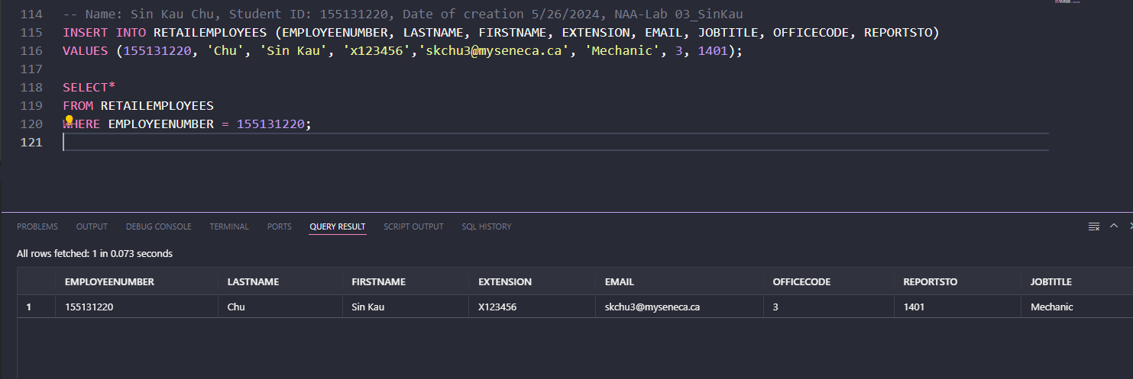

1. Create a query that displays your, and only your, RETAILEMPLOYEE data   
    
2. Create a statement to update your job title to “Senior Mechanic”   
    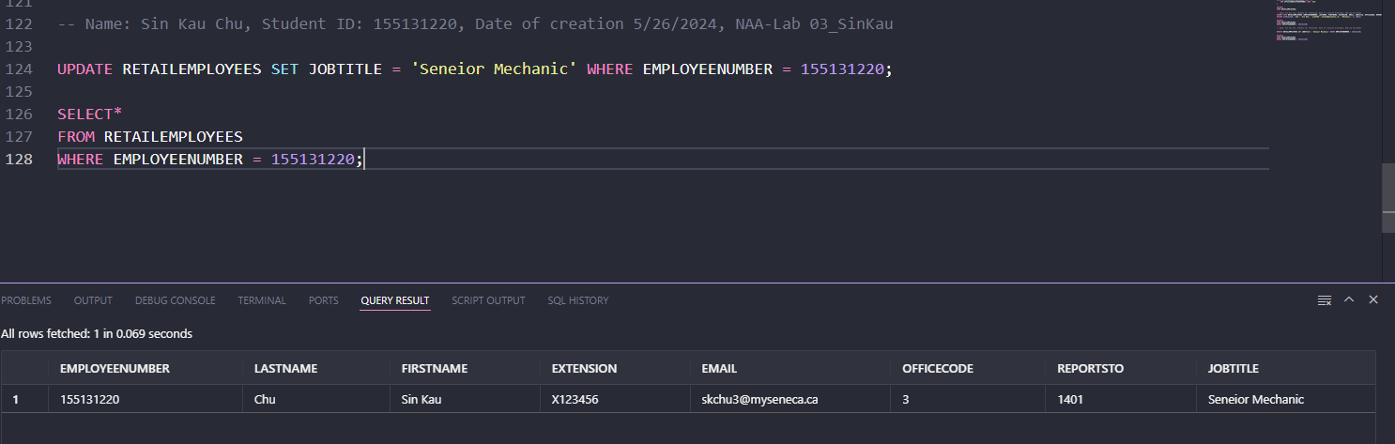
3. Create a statement to insert another fictional RETAILEMPLOYEE into the database.  This RETAILEMPLOYEE will be a “Manager” and will report to you.  Make up fake data for the other fields.

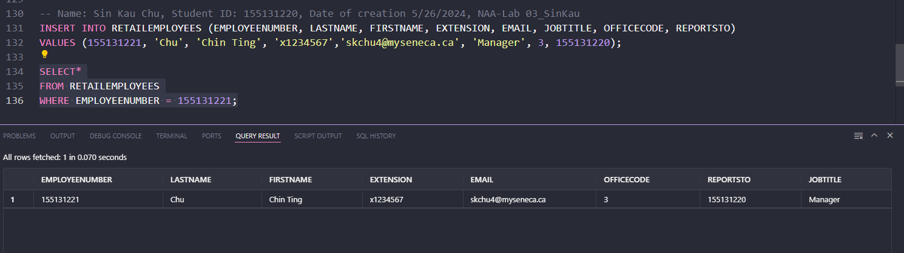

1. Create a statement to Delete yourself from the database.  Did it work?  If not, why?
2. Create a statement to delete the fake RETAILEMPLOYEE from the database and then rerun the statement to delete yourself.  Did it work?

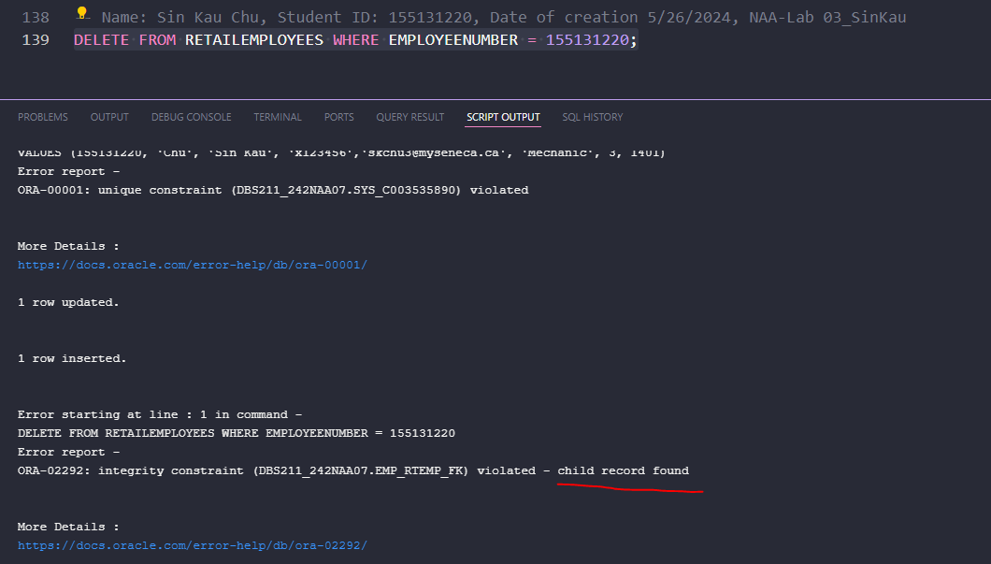

No, it did not work. As it was suggested that there was a child record found.

1. Create a **single** statement that will insert both yourself and the fake RETAILEMPLOYEE at the same time.  This time the fake RETAILEMPLOYEE will report to 1102 as well.



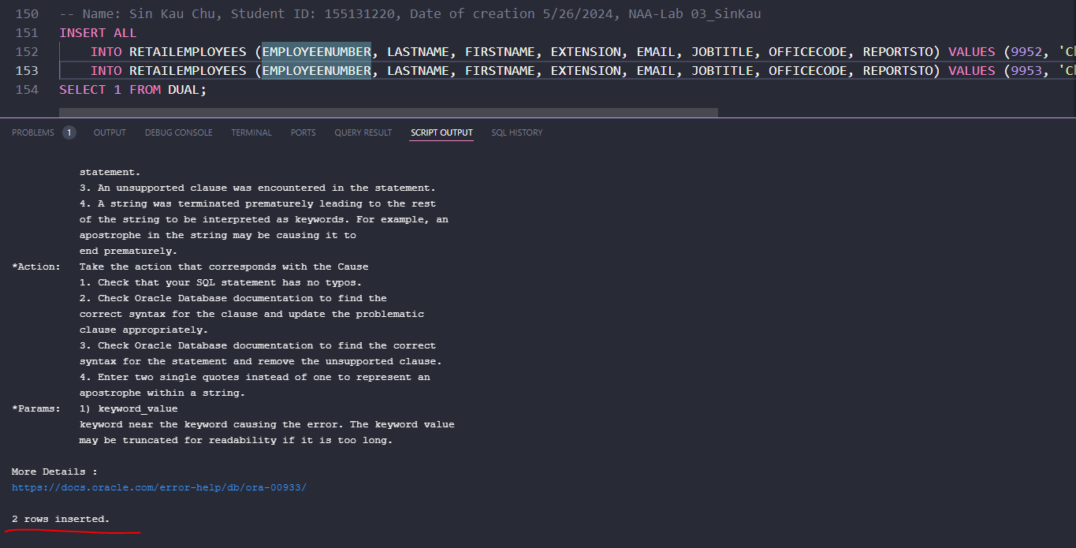

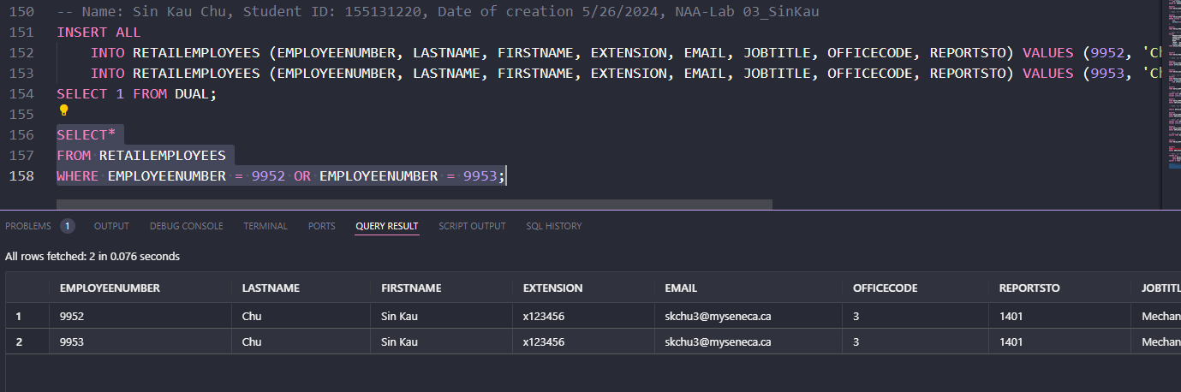

1. Create a **single** statement to delete both yourself and the fake RETAILEMPLOYEE.

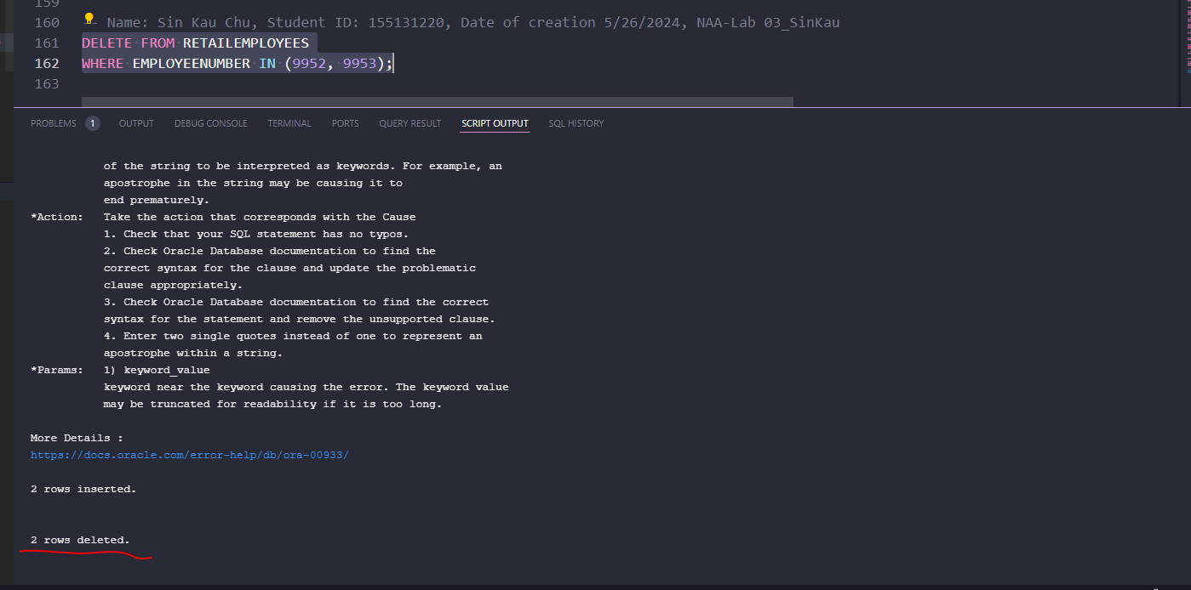

1. Create a new order in RETAILORDER table with required date Apr 20th ,2024 and order date as Apr 1st ,2024. Make up the reset of the fields and then display the only the new order that you have created just now.

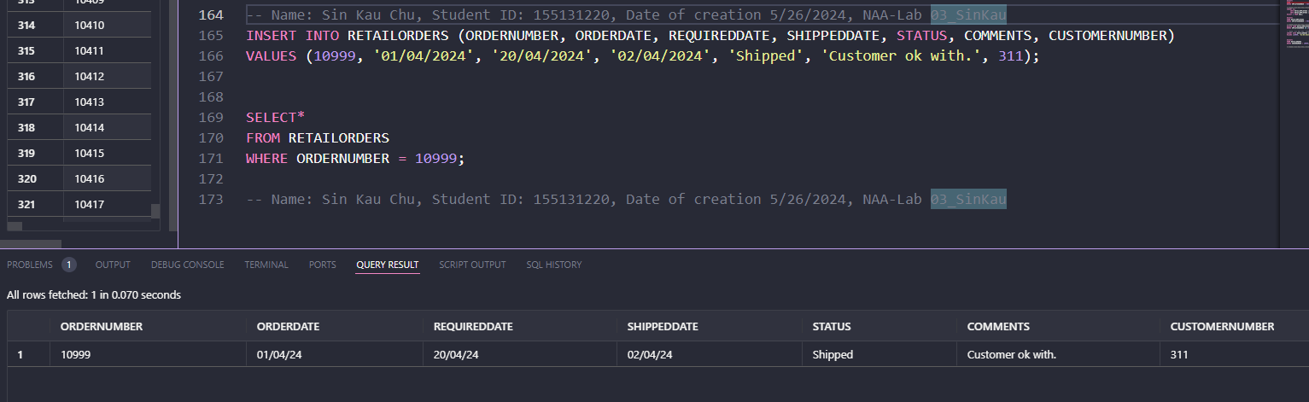

1. Insert a new product into product table with product name as “2024 Ferrari Portofino” and product code as “S20_2024” and make up the rest of the fields.

